# Manure Supply Curve Construction and Documentation

Prepared by Alex Badgett and Emily Newes,

National Renewable Energy Laboratory

# 1. Introduction

The National Renewable Energy Laboratory (NREL), on behalf of the U.S. Department of Energy’s Bioenergy Technology Office (BETO), is exploring the economic potential of the following wet Waste-to-Energy (WTE) feedstocks:

* Food Waste
* Fats, Oils, and Greases (FOG)
* Sewage Sludge
* Animal Manure

These materials are produced from various modern industries and are historically difficult to manage and safely dispose of. A low willingness to dispose of these wastes means that they could be available for use as bioenergy feedstocks, and at economically favorable costs. This document specifically discusses construction and evaluation of economic models for animal manure. In this instance, manure is defined as that produced from cattle, dairy, and swine at concentrated animal feed operations (CAFOs).

This work builds upon previous analysis in Milbrandt et al. 2017, which provides an assessment of the total and available wet WTE resource potential in the United States and illustrates their geographic distribution.

We build upon the aforementioned analysis by characterizing the economic drivers of animal manure management, and developing supply curves for the material. Understanding the economics of waste materials, which may not conventionally be treated as commodities by their handlers, requires a different, more flexible approach. The supply curves and parameters shown in this document depict material economics at a nationwide level, however future work intends to generate supply curves for states and regions.

Animal manure may or may not be assigned a value like a conventional commodity. Manure is most commonly applied to agricultural lands as a fertilizer, suggesting that it holds some economic value as a fertilizer to the farmers using it. This exact value can vary depending on how well manure meets the nutrient needs of adjacent agricultural lands. If the nutrient demand of adjacent croplands **exceeds** nutrients available in manure, the manure is valued based on its nutrient content. If the demand of croplands is **lower** than the amount of manure produced in the county, farmers are faced with finding someone willing to accept it or disposing of it in accordance with regulatory standards. Cost in this case is evaluated based on the cost of transporting and land applying the manure.

# 2. Process Flow

As noted in the prior section, demand (and therefore price) of manure varies spatially as a function of nutrient demand of adjacent agricultural cropland. Manure is commonly applied to crops and pasture lands as a supplemental fertilizer, as it contains valuable nutrients-mainly Nitrogen and Phosphorous. If a farm produces more manure nutrients than demanded by adjacent croplands the farmer must find another suitable disposal alternative. If no nearby cropland or pasturelands are available to land apply manure, farmers must pay the additional cost of hauling the manure to a suitable disposal site, be it more agricultural lands or a landfill.

Many dairy, swine, and cattle operations have progressed from larger to smaller footprints, combining bigger numbers of animals in a smaller area (CAFOs). CAFOs are of primary interest to this work as many do not grow crops in conjunction with animal feeding operations, reducing the available area on which they can apply the resulting manure.

EPA CAFO regulations and permits restrict sites at which farmers may land apply excess manure. Regulations prevent application of manure in ways that may overload the nutrient demand of the soil or cause unsafe runoff to adjacent waterways. This suggests that the relative ease at which farmers can dispose of excess manure is directly correlated with the acreage and type of cropland in the immediate vicinity of the farm, a metric central to the economic model developed for this analysis. Datasets for cropland acreage are available at the county level for the entire country; therefore each manure demand scenario was evaluated by county.

Through literature review and conversations with industry experts, three separate model scenarios were distinguished and depicted in this work. A general workflow is presented in Figure 1 and discussed in detail in the passages below.

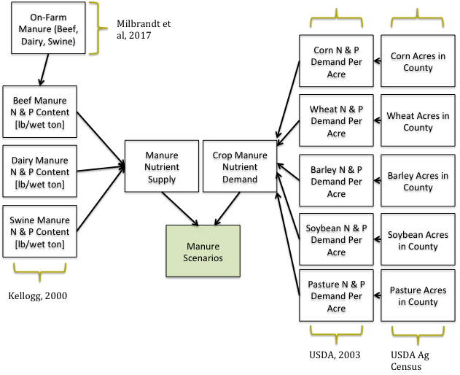

Figure 1: Model workflow for evaluating manure supply and demand within a county. Sources for the applicable datasets are noted outside the golden brackets.

The developed model uses a series of agronomic factors to estimate the amount of manure demanded by croplands within the county. The following equations show input variables used to estimate the amount (tons) of manure demanded for a given crop type.

when:

*Nn*=Nitrogen demand in the county for a given crop type [tons]

*A*=Acres of cropland planted in the county [acres]

*UN*=Average crop-specific Nitrogen uptake rate [lbs N/acre]

An identical operation is conducted for phosphorous demand (*Np*) rates for each crop type in the county. Table 1 values are used to calculate manure demand across different crop types.

Table 1: Nitrogen and Phosphorous demands for different crop types (USDA, 2003)

|  |  |  |  |  |  |
| --- | --- | --- | --- | --- | --- |
|  | Corn | Soybeans | Wheat | Barley | Pasture |
| N Demand [lb/acre] | 97.5 | 115 | 40 | 54 | 75 |
| P Demand [lb/acre] | 16.5 | 12 | 7 | 11 | 30 |

These values are then inputted into the below equation to identify the total manure nutrients demanded by different crops within the county.

when:

*Md*= Crop manure nutrient demand [tons]

*Nn*= Nitrogen demand in the county for a given crop type [tons]

*Np*= Phosphorous demand in the county for a given crop type [tons]

*DAD*=Demand of livestock anaerobic digesters in the county [tons]

The above equation uses the max nitrogen or phosphorous nutrients demanded by a particular crop type within the county and models this value as the demand for that crop. This operation reflects the fact that manure is commonly applied by either nitrogen or phosphorous nutrient demands, and not both.[1] The model presumes that the maximum demanded nutrient is what determines the amount of manure to be land applied. These operations are run for each of the four crop types considered as well as pasturelands. The total manure demand for the county is the sum of demand for each land type, as shown in the following equation:

when:

*Mdt*=County manure nutrient demand [wet tons]

*Md*=Manure demand for cropland type [wet tons]

The developed manure demand determination is a likely optimistic take on the demand for manure within the county, as it assumes that all agricultural crop and pasture lands are available for use as land application sites. Crop rotations, rough topography, and logistical access often reduce the overall acreage available for land application of manure.

Figure 2 illustrates the three distinguished manure scenarios possible within the model. The scenarios are discussed in detail below.

Manure Demand & Supply

Manure Marketed as a Commodity

Manure Exceeds Cropland Demand

Manure Meets Cropland Demand

Manure Fraction used by Crops

Price Evaluated as Fertilizer

Excess Manure Fraction

Price Evaluated as Land Application and Transport Cost

Model Scenarios

Cost Evaluation

Figure 2: Model scenarios and corresponding cost evaluations as shown.

## 1. Manure Meets Cropland Demand

The demand for manure as a fertilizer across agricultural lands is directly correlated to the acreage and rate (ton/acre) manure can be applied to the land. This scenario represents situations where the tonnage of manure is less than that demanded by the cropland within the county. In this scenario, it is presumed that farmers are best suited to keep manure on site and use it as a supplemental fertilizer. Since farmers are using manure to supplement the amount of fertilizers purchased to grow their crops, the manure is priced per ton based on its nutrient (N & P) content.

## 2. Manure Marketed as a Commodity

Through conversations with industry experts, it was identified that some areas of the country have developed markets for animal manure used as a fertilizer. In these cases, manure can be handled as a marketable commodity, with brokers connecting buyers and sellers. These areas often exhibit a high concentration of CAFOs with lots of agricultural acreage nearby. The key factors driving these scenarios are both the type of manure available and the distance from source to field.

Animal manure holds different nutrient content and therefore different value. Manure can either directly contribute nutrients needed by crops or not meet the nutrient needs of the land, forcing it to be managed in another way. The relative worth of manure varies on the production and consumption ends. Animal diets, climatic effects, manure storage and type of cropland all play into how well manure meets the nutrient needs of cropland. Due to the highly localized scale of these factors, they are not captured in the developed model. In the commodity scenario, adjacent croplands benefit from manure application sufficiently for farmers to be willing to pay for the material.

A web search for developed manure markets and brokers was conducted to identify areas where manure is primarily managed as a commodity. Several states were identified, however the majorities were focused on poultry litter or other manures with lower water content. This analysis is specific to manure produced at beef, dairy and swine CAFOs, which appear to exhibit much more irregular markets.

Glewen and Koelsch, 2001a and 2001b conducted a survey of feedlots in the state of Nebraska to identify existing markets and cost structuring of said markets. This article was the only one reviewed that noted that markets exist for manure that are not specific to poultry feedlots. Glewen and Koelsch noted that of farms that export manure, approximately 50% of farms marketed (sold) manure as a fertilizer while the other half gave it away at no cost. The developed cost model accounts for this in the state of Nebraska by partitioning half of excess manure cost as the fertilizer value of the manure and the other half as the cost of hauling and land applying it.

Also of note is a manure relocation program implemented by the state of Delaware, designed specifically for poultry litter. (EPA, 2017) The program credits farmers $0.16 per mile per ton to relocate poultry litter. As poultry litter is not considered within this analysis the model does not account for this program, however it does serve as a testament to the markets for manure that have/are being developed.

## 3. Manure Exceeds Cropland Demand

This scenario maps counties where the amount of manure produced exceeds the acres of cropland needed to land apply the manure in accordance with the defined agronomic rates. This is a key scenario for the feasibility of manure being used as a WTE feedstock, as excess manure burdens producers with finding a party willing to accept the excess manure. The model presumes that these farms are willing to transport excess manure to a land application site within a specified distance and apply the manure themselves. The amount of excess manure is estimated on a farm-by-farm basis by the following equation:

when:

*Mexcess*=Excess manure per farm in the county [wet tons/farm]

*Ms*=Manure supply for the county [wet tons]

*Md*=Manure demanded by cropland and pasture in the county [wet tons]

*Nfarms*=Number of CAFOs mapped in the county [farms]

If the model determines that the amount of manure produced within the element exceeds the available cropland capacity, the difference between demand and supply is calculated. Cost evaluation for the excess portion of manure in an element is approached differently than the method of nutrient content value used in Scenarios 1 and 2. As the manure is considered excess and must be managed somewhere else, the model assumes that manure is hauled to another land application site. Costs are calculated via the below equation:

when:

*Cex*=cost for hauling and land applying excess manure [$/wet ton]

*ACC*=amortized capital costs for tractor and manure application system [$/year]

*OMC*=operations and maintenance costs for tractor and spreader. Includes labor and fuel costs. [$/year]

*Mexcess*=Excess manure produced per farm on a yearly basis [wet tons/year]

In this equation the farmer is responsible for hauling manure and land applying it at another site. The model computes a dollar per ton value for hauling and land applying manure along with amortized capital costs for a tractor and spreader. These costs are mapped as negative because it is assumed that farmers would be willing to pay anything less than their current cost (*Cex*) to have someone else take the excess manure. These economics could favor both the farmer and consumer, as farmers are able to dispose of manure at a lesser cost while consumers secure an economically favorable WTE feedstock.

## Data

Collection and processing of the datasets needed to model the cost of manure across the United States was done at the most localized scale possible. Modeling required aggregation of extensive datasets on farming operations and infrastructure in conjunction with statistics on fuel, labor and other economic parameters. As expected with varied data sources, available spatial resolution of model parameters varies. Point resolution for corn acreage is not possible given that it describes areas of land, unlike the locations of individual CAFOs. This illustrates a key issue discussed later in this text: the spatial relationships between CAFOs and cropland that manure is applied to. This is discussed further in Section 3.

Table 2 lists a series of datasets used in this work and the spatial resolution of each. As the source of each dataset used varies from Milbrandt et al. 2017 to USDA to the U.S. Bureau of Labor Statistics, the resolution of each also varies.

Table 2: Sample of varied spatial resolution between datasets used in this analysis

|  |  |  |
| --- | --- | --- |
| Point Resolution | County Resolution | State Resolution |
| CAFO Manure Production (Milbrandt et al. 2017) | Crop acreages (USDA, 2016) | Farm labor (BLS, 2016) |
|  |  | Prices of electricity & Fuel (EIA, 2017a, 2017b) |
|  |  | Rates of manure application by crop type (Kellogg, 2000) |
|  |  | Fertilizer costs (USDA, 2016) |
|  |  | Anaerobic Digester Demand (EPA, 2016) |

# 3. Limitations

Any high level, initial analysis such as this is subject to several limitations, the most notable of which are discussed in this section. Limitations exist in the scenario definition, model scope, and cost evaluations.

## Geographic Factors

As presented in the data section, all efforts were made to aggregate datasets at the finest resolution possible. This still leaves something to be desired with respect to modeling how manure is managed on CAFOs. As the cost to haul liquid and slurry manures is high and often times prohibitive, farmers attempt to minimize distance traveled when land applying excess manure by land applying manure on croplands. Acreage for corn, soybeans, barley, wheat, and pastureland was aggregated at the county level, and this model therefore does not sufficiently capture which CAFOs are able to dispose of excess manure at nearby croplands and which incur more costs for hauling the manure longer distances.

Figure 3 illustrates the disconnect between using point sources for manure sourced at CAFOs and land available for land application of excess manure, using corn acreage within the state of Iowa as an example. Supply of manure is computed at each gold point (CAFO) and summed by county. The acreage of cropland and pasture is also summed across the county, and the manure nutrient demand computed from that value (illustrated by red color gradient in each county). This constrains the manure supply/demand computation to factors within the county itself. In reality CAFOs near county boundaries may choose to haul manure across county borders to areas with more available cropland. As seen in the figure, the majority of CAFOs are located in the Northwestern corner of the state, while the majority of corn is in counties further south. Movement of manure from county to county is not captured within this model because the distances required are often not economically feasible for farmers; however, in reality it varies in feasibility from site to site.

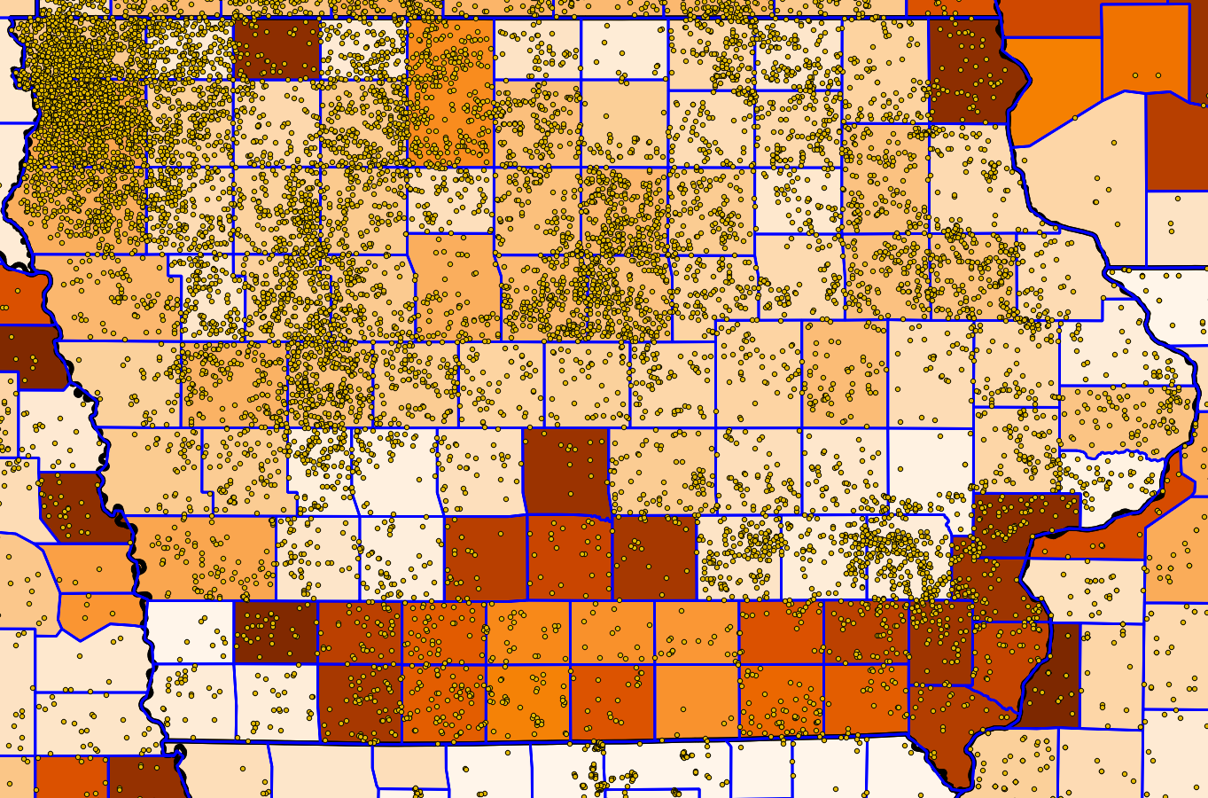

Figure 3: State and county map of Iowa, with CAFOs marked by yellow dots and acres of corn shaded red by county. Counties with higher acreage of corn are noted with a darker fill.

## Manure as Fertilizer Cost Evaluation

Animal manure contains a valuable amount of nutrients, most of which is used as a supplemental fertilizer on pastures and croplands nearby the source. The fertilizer value of manure is computed using a series of assumed values for Nitrogen, and Phosphorous within the manure (lbs/ton). Dollar per pound prices for each component are used to quantify the fertilizer value of the manure.

Manure value as fertilizer depends on several factors not captured in this model, however. Per CAFO permit criteria, manure is required to be land applied at agronomic rates suitable for the site. These rates are identified through soil testing, and several metrics can be used to quantify the amount of manure needed to meet the crop demands. These metrics can vary by crop type and area, as different climates require different techniques, and different crops require different nutrients.

Manure value as a fertilizer is therefore dependent on the land applied crop, manure nutrient content and other geographic factors, something not captured within this model.

# 5. Supply Curves

Resulting supply curves for animal manure across the entire country showed two separate cost drivers at play:

* Excess manure that cannot be land applied within the model element (Scenario 3, negative cost feedstock)
* Manure used on-farm as fertilizer or marketed as a fertilizer to other buyers (Scenarios 1 and 2, positive cost feedstock)

These two scenarios result in a supply curve existing on both the negative and positive sections of the Y-axis. These positive and negative costs are computed from the perspective of feedstock consumers, and in other words are the value they could expect to pay to purchase the feedstock. Negative costs suggest that farmers would be willing to pay the consumers some dollar amount to take the feedstock for them, while positive costs indicate that they would need to pay producers of manure to acquire the material.

The national supply curve shown in Figure 4 indicates that the overall supply of manure is divided between positive and negative costs. It shows that the excess portion of manure (not needed for land application) is available at a negative or zero cost, while the portion used as fertilizer on agricultural lands is more of a commodity and would require a user pay to acquire it.

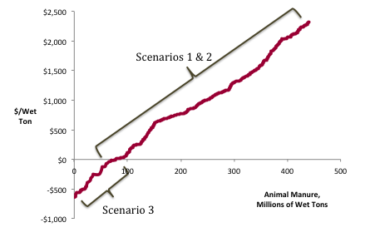

Figure 4: Annotated national scale supply curve for animal manure. Manure on the negative portion of the figure fits within the excess manure scenario, while the supply on the positive end is managed as a commoditized fertilizer.

The following Figures 5 and 6 break down components of excess and fertilizer manure between states, by percentage and volume.

A number of states were omitted from this analysis due to lack of data coverage and negligible manure supply. Reference Milbrandt et al, 2017 for further discussion.

These figures indicate that higher overall tonnage of animal manure production does not necessarily correlate to more excess manure. States with the highest manure production also have extensive amounts of agricultural acreage, providing sufficient acreage to land apply the animal manure. It appears that Western states are more likely to produce excess manure, as they lack the high acreage of cropland seen in midwestern states.

Figure 5: Manure Distribution by state of manure used as fertilizer and excess.

Figure 6: Excess and fertilizer manure by state in wet tons.

Figure 7 maps model run results for individual types of manure, rather than the sum of all three types. The curves clearly suggest that the majority of excess manure across the US results from dairy CAFO operations, as the dairy curve shows the most negative cost. It should be noted that these runs may not necessarily capture the entirety of excess manure by type, however. Each run assumed that all land area in the county was available for land application, when in reality competition for land application acreage is possible between the different manure types. As feedlot operations between swine, beef, and dairy sectors are commonly geographically separate, competition between the types is presumed to be minimal, and in this case is neglected.

Figure 7: Segmented supply curves for swine, dairy, and beef manure.

Figure 8: Supply curves for selected states illustrating different proportions of manure used as fertilizer (commoditized) and excess manure

# 6. Process Scenarios

The following points describe scenarios identified during model construction that may be of interest to build understanding of the economics of manure on CAFOs:

* Modification of “willingness to accept manure” metric for different areas
* Including storage cost scenario for the largest CAFOs
* Landfill disposal for CAFOs close to population centers

# 8. References

“Average Price of Electricity to Ultimate Customers by End-Use Sector.” 2017a. United States Energy Information Administration. https://www.eia.gov/electricity/monthly/epm_table_grapher.php?t=epmt_5_6_a.

“Costs Associated with Development and Implementation of Comprehensive Nutrient Management Plans: Appendix.” 2003. United States Department of Agriculture.

“Delaware Manure Relocation Program.” 2017. United States Environmental Protection Agency. https://www.epa.gov/sites/production/files/2017-01/documents/b_delaware_manure_relocation_program.pdf.

“Gasoline and Diesel Fuel Update.” 2017b. United States Energy Information Administration. https://www.eia.gov/petroleum/gasdiesel/.

Glewen, Keith, and Rick Koelsch. 2001a. “Marketing Manure Part 1.” *University of Nebraska Lincoln Biological Systems Engineering* 7 (5).

———. 2001b. “Marketing Manure Part 2.” *University of Nebraska Lincoln Biological Systems Engineering* 7 (6).

Kellogg, Robert, Charles Lander, David Moffitt, and Noel Gollehon. 2000. “Manure Nutrients Relative to the Capacity of Cropland and Pastureland to Assimilate Nutrients: Spatial and Temporal Trends for the United States.” nps00-0579. United States Department of Agriculture.

Milbrandt, A. Seiple, T., Heimiller, D., Coleman, A., Skaggs, R. (2017). “Wet Waste-to-Energy Resource Assessment”. Pending publication, Biomass and Bioenergy Journal.

“National Agriculture Statistics Service.” 2016. United States Department of Agriculture. https://quickstats.nass.usda.gov/.

“Occupation: Agricultural Equipment Operators.” 2016. United States Bureau of Labor Statistics. bls.gov.

1. Needs confirmation by an expert.